I have not taken help from anyone or provided help to anyone about this quiz and the answers I have provided are completely based on my own understanding.
_DOV CATTAN 4/22/21_
Sign and date
Problem 1 [10]

The following table shows the contents of two different data segments of a MSP430 memory map.
- What is the byte stored at location 0x0305? Answer: _____60________
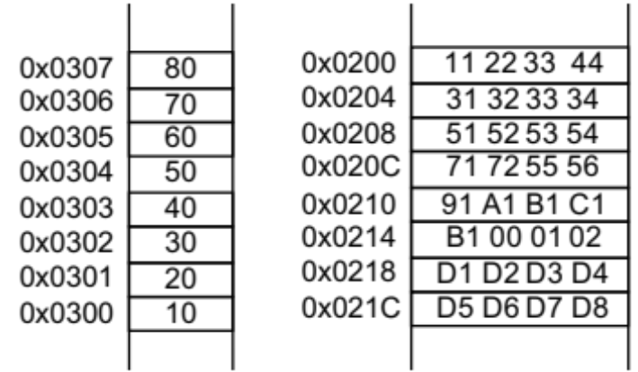
- What is the word stored at location 0x0302? Answer: _____40 30_______
- What is the byte stored at location 0x0208? Answer: _______51
- What is the byte stored at location 0x0205? Answer: ________32______
- What is the word stored at location 0x0216? Answer: _____02 01_____

Problem 2 [30]
For each of the following program segments, execute the program one instruction at a time. At the end of the execution of each instruction, indicate any changes in registers, condition flags, and/or memory locations. Note that the result of an instruction may be an operand for succeeding instructions.

 | N | Z | V | C | R5 | R6 |  | Address | Data | Result
Instruction | 0 | 0 | 1 | 0 | 0x1234 | 0xA006 |  | 0x0200 | 0x5800 | 5800
mov.w #0x5959, R5 | 0 | 0 | 1 | 0 | 0x5959 | 0xA006 |  | 0x0202 | 0x5700 | 5700
mov.w #0x0206, R6 | 0 | 0 | 1 | 0 | 0x5959 | 0x0206 |  | 0x0204 | 0x5600 | 5600
mov.b R5, 0(R6) | 0 | 0 | 1 | 0 | 0x5959 | 0x0206 |  | 0x0206 | 0x5500 | 5559
 | N | Z | V | C | R5 | R6 |  | Address | Data | Result
Instruction | 1 | 0 | 1 | 0 | 0x0202 | 0x0204 |  | 0x0200 | 0x8800 | 8700
mov.w @R5+, -4(R6) | 1 | 0 | 1 | 0 | 0x0204 | 0x0204 |  | 0x0202 | 0x8700 | 78FF
xor.b 0(R5), R6 | 0 | 0 | 0 | 1 | 0x0204 | 0x0204 |  | 0x0204 | 0x8600 | 8600
inv.w -2(R5) | 0 | 0 | 1 | 1 | 0x0204 | 0x0204 |  | 0x0206 | 0x8500 | 8500
 | N | Z | V | C | R5 | R6 |  | Address | Data | Result
Instruction | 0 | 0 | 1 | 1 | 0x0101 | 0x0204 |  | 0x0200 | 0x9808 | 9808
addc.w R5, 2(R6) | 1 | 0 | 0 | 0 | 0x0101 | 0x0204 |  | 0x0202 | 0x9707 | 9783
decd.w R6 | 0 | 0 | 0 | 1 | 0x0101 | 0x0202 |  | 0x0204 | 0x9606 | 9606
rrc.b 0(R6) | 1 | 0 | 0 | 1 | 0x0101 | 0x0202 |  | 0x0206 | 0x9505 | 9607
Problem 3 [40]
In data communication systems, we often need to find a specific sequence of bits in a data stream. We want to use MSP430 for that purpose. Please write an MPS430 assembly language subroutine “BITSEQ” that examines the contents of register R6 and looks for a 4-bit sequence “1001”. The subroutine will count the number of times this sequence (1001) occurs in R6 and puts that count in R7. The contents of R6 need to be preserved. Please include clear and specific comments for each instruction.

BITSEQ
// Begin Bit Sequence Subroutine
mov.b #13, R11 //set the loop counter to 13 using 16 - 4 bits +1
clr R12 // clear R12 register
clr R7 // clear R7 register
LOOP
// Begin Loop Subroutine
mov.b R6,R8 // copy R6 register to
and.b #0x000F,R8 // register 0x000F and R8 becomes R8
cmp.b #0x0009,R8 // compare register 0x0009 and R8
jne SKIP // jump to SKIP
inc R7 // increment R7
SKIP
//Begin Skip Subroutine
rrc R6 // Roll the carry of register R6 to the right
dec R11 //decrement register R11
jnz LOOP // jump to LOOP
ret
//end code

Problem 4 [20]
For the following MSP430 C program, fill in the comments next to the // to indicate the function of the corresponding line. Be brief and be specific in your comments. Take hint from the existing comments.

#include <msp430g2553.h>

#define LED1 BIT0 //LED1 equated to BIT0
#define LED2 BIT6 // LED 2 equated to BIT6
#define BUTTON BIT3 // BUTTON equated to BIT3

unsigned int folds = 1;
int i=1;

void main(void)
{
WDTCTL = WDTPW + WDTHOLD; //Stop watchdog timer

P1OUT = 0x00; //make sure all default outputs are zero
P1DIR = 0x00; //set Port 1 to all inputs
P1DIR = (LED1 | LED2); // set P1.0 and P1.6 to output direction

P1REN | = BUTTON; //enables internal resistor on the button pin
P1OUT &= BUTTON; //selects resistor as a pull down
P1IES &= BUTTON; // interrupt positive edge select, low to high
P1IE |= BUTTON; // enable interrupt on selected pin
__enable_interrupt(); //enable interrupts activities

for (;;)
{
P1OUT ^= (LED2); //toggle LED2 on P1.6 using XOR
For (i = 1; i <= folds; i++) //for a number of times equal to folds,
{__delay_cycles(100000);} // run delay of 100,000 micro seconds
}
}

// Port 1 interrupt service routine
#pragma vector=PORT1_VECTOR
__interrupt void Port_1(void)
{
P1OUT |= LED1; //LED1 on to indicate beginning of interrupt service
folds ++; if (folds >= 6) {folds =1;} // increment folds; cycle folds for 1,2,3,4 and 5
__delay_cycles(20000); //allow some delay for switch debounce
P1IFG &= ~BUTTON; // P1.3 IFG cleared
__delay_cycles(20000); //allow some delay for switch debounce
P1OUT &= ~LED1; // LED1 off to indicate end of interrupt
}

